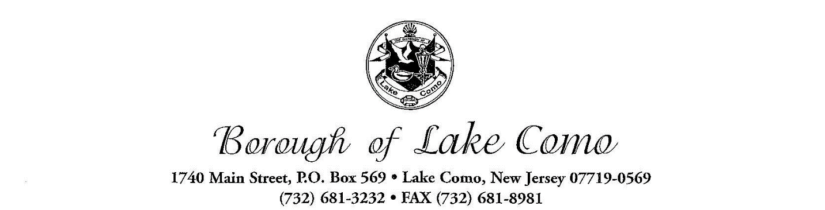

PLANNING BOARD APPLICATION

FOR MUNICIPAL USE ONLY

Application Number: ____________________________
Received By: ____________________________
Fees Collected: ____________________________
Hearing Date: ____________________________
Resolution Adopted By Board: ____________________________
Granted Denied
_____________________________________________________________________________________
If something is not applicable to the application being submitted, please specify with N/A

- Applicant(s) Name, Address & Telephone Number
__________________________________________________________________________________________________________________________________________________________________________________________________________________________________________
- If the applicant is being represented by an attorney, please state name, address & telephone number
__________________________________________________________________________________________________________________________________________________________________________________________________________________________________________
- Applicant is:
Corporation Partnership Individual Other _______________________________
NOTE: If application is a corporation or a partnership, please attach a list of the names and addresses of persons having a 10% interest or more in the corporation or partnership.
- The relationship of applicant to the property in question is:
Owner Lessee
- If applicant is not Owner, please state name, address and telephone number of the owner:
__________________________________________________________________________________________________________________________________________________________________________________________________________________________________________

- Application is a request for the following:
- Preliminary Site Plan
- Final Site Plan
- Joint Preliminary and Final Site Plan
- Minor Subdivision (3 or less lots)
- Preliminary Subdivision
- Final Subdivision
- Joint Preliminary and Final Subdivision
- Variance requests, including bulk or use variances – please specify
  - ________________________________________________________________________________________________________________________________________
- Informal Hearing
- Give a brief description of application:
__________________________________________________________________________________________________________________________________________________________________________________________________________________________________________
- Street Address of Property:
______________________________________________________________________________
Block: _______________ Lot: _______________
- Use of Property: ________________________
Existing: ________________________
Zone: ________________________
Proposed: ________________________
Lot Area: ________________________
Building Area: ________________________
- Map Information: ________________________
Map Dated: ________________________
Prepared By: ________________________
Map Entitled: ________________________
- Additional comments by applicant which may be relevant to hearing:
__________________________________________________________________________________________________________________________________________________________________________________________________________________________________________

I certify that the statements and information contained in the application are true. I authorize the applicant to submit this application and process for approval
________________ _____________________________________________
Date Applicant/Agent

GENERAL INFORMATION
Meeting Dates: As published pursuant to N.J.S.A. 40:55D-9 et and additional meetings scheduled as required.

Time & Place: 7:00pm
Lake Como Borough Hall Meeting Room
1740 Main Street, Lake Como, NJ 07719

Chairman: Joseph Cavaluzzi

Attorney: Adam Schneider, Esq.

PROCEDURES CHECKLIST:
Submit following with each application
- One (1) original and three (3) copies of application form. Fill out application in its entirety. Answer all questions pertaining to your application. Update all tax information from Tax Collector/Assessor’s office.
- Appropriate fee-check made payable to the Borough of Lake Como in accordance with fee schedule.
- Include fifteen (15) full size prints of site plan and/or subdivision map and/or survey and/or photographs as required. Survey should be signed, certified and dated within last ten (10) years. **PLEASE FOLD PLANS, DO NOT ROLL**
Major Subdivision ______________________
Minor Subdivision (3 or less lots) ______________________
Preliminary Subdivision ______________________
Final Subdivision ______________________
Site Plan – Preliminary ______________________
Site Plan – Final ______________________
Hardship variance(s) – Single Family ______________________
Informal ______________________
Other ______________________

NOTE: When an application includes request for more than one action, the total accumulated for each action shall be collected. No application will be scheduled for hearing unless it is considered complete at least 21 days prior to the meeting date.

NOTE: When application represents requests for both preliminary and final approval simultaneously, both fees shall be collected.

